Harvard Bok Higher Education Teaching Certificate Online Short Course

The United Board for Christian Higher Education in Asia offered scholarship to selected educators in its network for the Harvard Bok Higher Education Teaching Certificate Online Short Course.
The eight-week online course was designed by faculty members from Harvard University's Derek Bok Center with content knowledge, pedagogical knowledge and technological knowledge. The course demonstrates how content, pedagogy and technology can be designed to ensure high quality education. To be successful in the course, one must have good time management for reading and doing assignments, such as discussion forums, peer reviews, essay writing, and so on.
Four educators from Sanata Dharma University were selected for the Harvard Bok online course by virtue of their being the leaders of two projects that were earlier approved for grants by the United Board.
Two lecturers, Dr. F.X. Ouda Teda Ena from the Master of English Education Study Program and Dr. Monica Eviandaru Madyaningrum from the Psychology Study Program were among the first batch of United Board supported participants who took the course in July to September 2020. They are the project leaders of the national training hub for Whole Person Education for Eastern Indonesia and Timor Leste. Ms. Truly Almendo Pasaribu from the English Language Education Study Program and Dr. Theresia Enny Anggraini from the English Literature Study Program joined the program from October to December 2020. They are the project leaders for the Intensive English Language Program for Internationalization for Eastern Indonesia and Timor Leste.
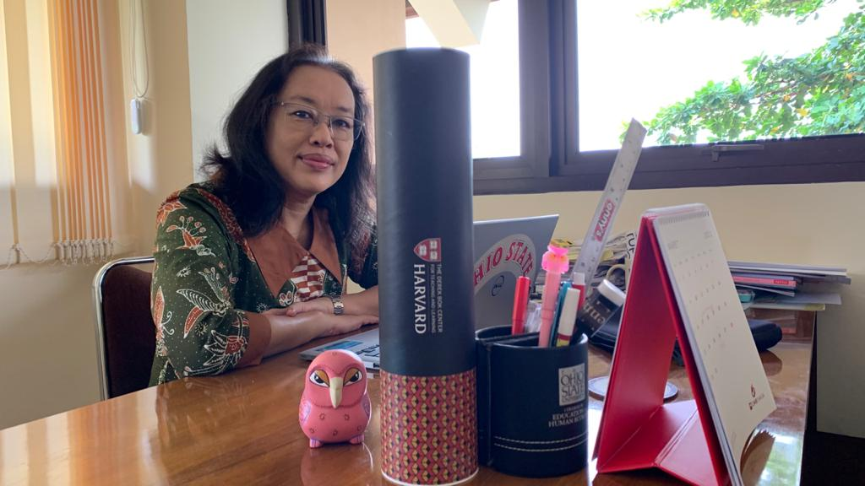
After completing the online course, the educators felt they received many benefits that could be applied in their teaching and shared with other lecturers. In her testimony Dr. Enny writes, "Thank you to the United Board and Sanata Dharma University for providing the opportunity to take courses at the Harvard Derek Bok Center. This course on Outcome Based Education and Backward Design is very useful, especially in recent times, with the launch of an OBE curriculum for tertiary institutions. This asynchronous online course is very neat and easy to follow the steps so that not only is the content very useful, but the way it is delivered can also be an example in compiling online lectures." She appreciated the program’s orderliness and convenience, and its relevance for the university curriculum.
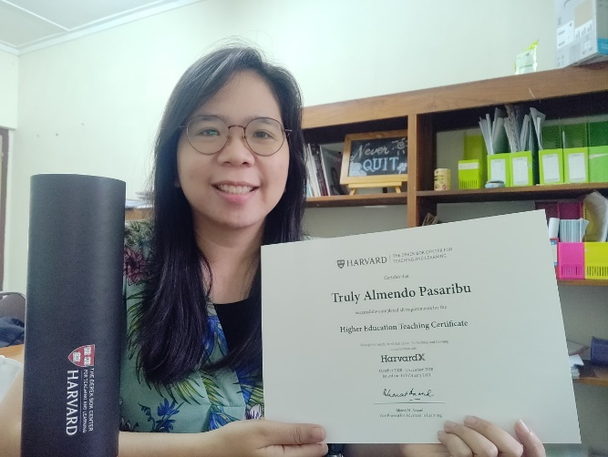
Ms. Truly was satisfied with the systematic program. She writes, "The experience of joining the Higher Education Teaching Certificate program by Harvard's Derek Bok and HardvardX is a very memorable experience. This program, which is systematically designed through the Moodle platform, highlights the importance of reflective, collaborative, holistic and targeted learning. Teaching principles that are in line with the spirit of Cura Personalis at Sanata Dharma University, including Backward Design, Universal Design for Learning, Engaging Learners, Assessment, are conveyed through a variety of readings, videos, infographics and interactive quizzes. Like Dr. Enny, Ms Truly has adopted some things from the program in her teaching. “After attending asynchronous learning, I compiled and collected a teaching portfolio containing teaching philosophy, syllabus, learning videos, class activities and assessment instruments for the Introduction to Sociolinguistics course. These experiences highlight AHA moments that can be applied immediately in the classroom", Ms. Truly writes in her testimony.
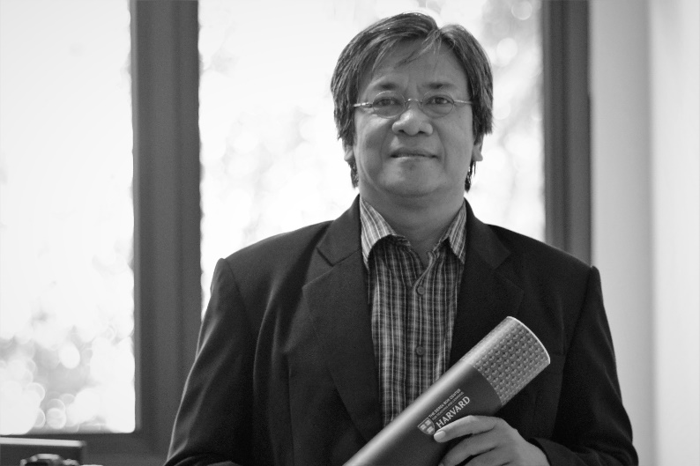
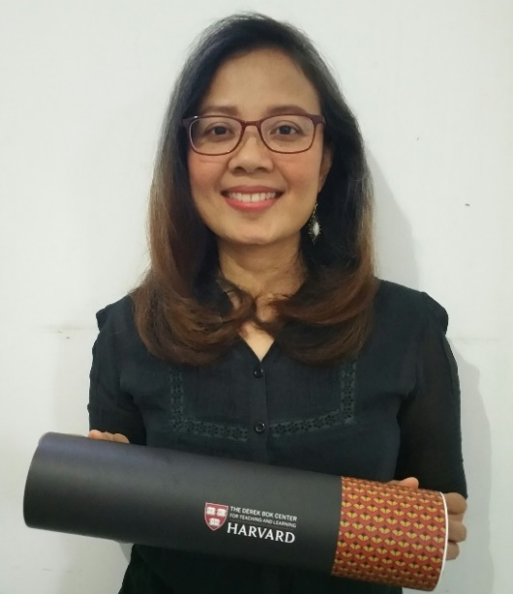
Dr. Monica writes in her testimony, "Taking the Harvard Teaching Certificate Course is an opportunity to do international benchmarking on teaching practices and experiences. Meetings with facilitators and study partners from various countries provide an opportunity to identify good practices that have become part of the teaching and learning tradition at Sanata Dharma University which are seen internationally as a superior pedagogical paradigm and practice. " From this Harvard program, she feels proud that the educational practices at Sanata Dharma University have met international standard.
Dr. Ouda also got a lot of insights about online learning from the Harvard program. "This Higher Education Teaching Certificate Online Short Course demands hard work and high commitment. This helps me to design online learning programs for my students. Being an online learner helped me to be more empathetic and to realize that there is a digital divide in online learning that has to be addressed because of the pandemic. This program provides a lot of inspiration for the design of online learning because I had the opportunity to exchange ideas with program participants from various countries and various disciplines”, Dr. Ouda writes in his testimony.

